SensePi GUI Manual
Version 1, 15.12.2025
Introduction:
This manual is related to the setup shown in Figure 1, which consists of a Raspberry Pi Zero 2 WH acting as the main computer that runs the logger/software and communicates with the sensor over I2C while streaming/recording data over the network, powered through a Geekworm X306 V1.3 ultra-thin UPS shield supplied by USB-C and backed up by a single rechargeable 3.7 V battery cell; a Freenove GPIO breakout block HAT is used to provide clean, reliable wiring access to the Pi’s 40-pin GPIO, and the motion data is measured by 3 MPU-6050 (GY-521) IMU module that provides 3-axis acceleration and 3-axis gyroscope measurements via I2C.

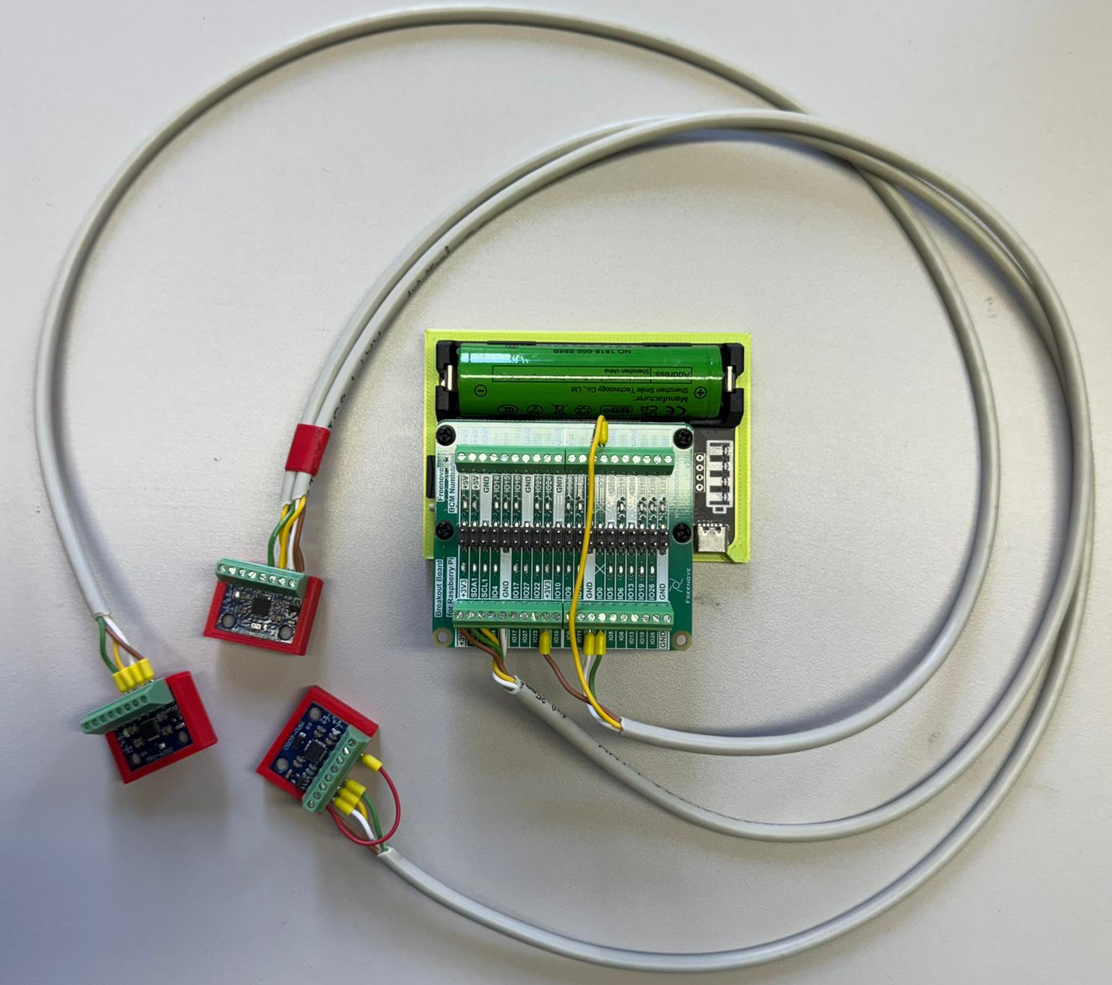
Figure 1: SensePi setup.

This manual shows how to operate the SensePi for data acquisition. For installation, please refer to the readme.md file in the repository.

1. Raspberry Pi credentials:
user: “verwalter”
password: “66442200”
Network settings: the Raspberry Pi needs to connect to a a wirless adapater with the name ‘MissionControl’ and with a password ”!6644200”. The pi’s has fixed ip address (e.g. 192.168.0.103), and the router should be set up to be in the same range.

2. Run main.py :
Run the main.py file in your IDE or in terminal with the command (python main.py).
SensePi’s main window, as shown in Figure 2, is a tabbed interface:
- Live Signals – starts/stops streaming and shows time‑domain plots
- Spectrum – FFT/spectrum view
- Settings – where you set up Raspberry Pi hosts and sensor defaults
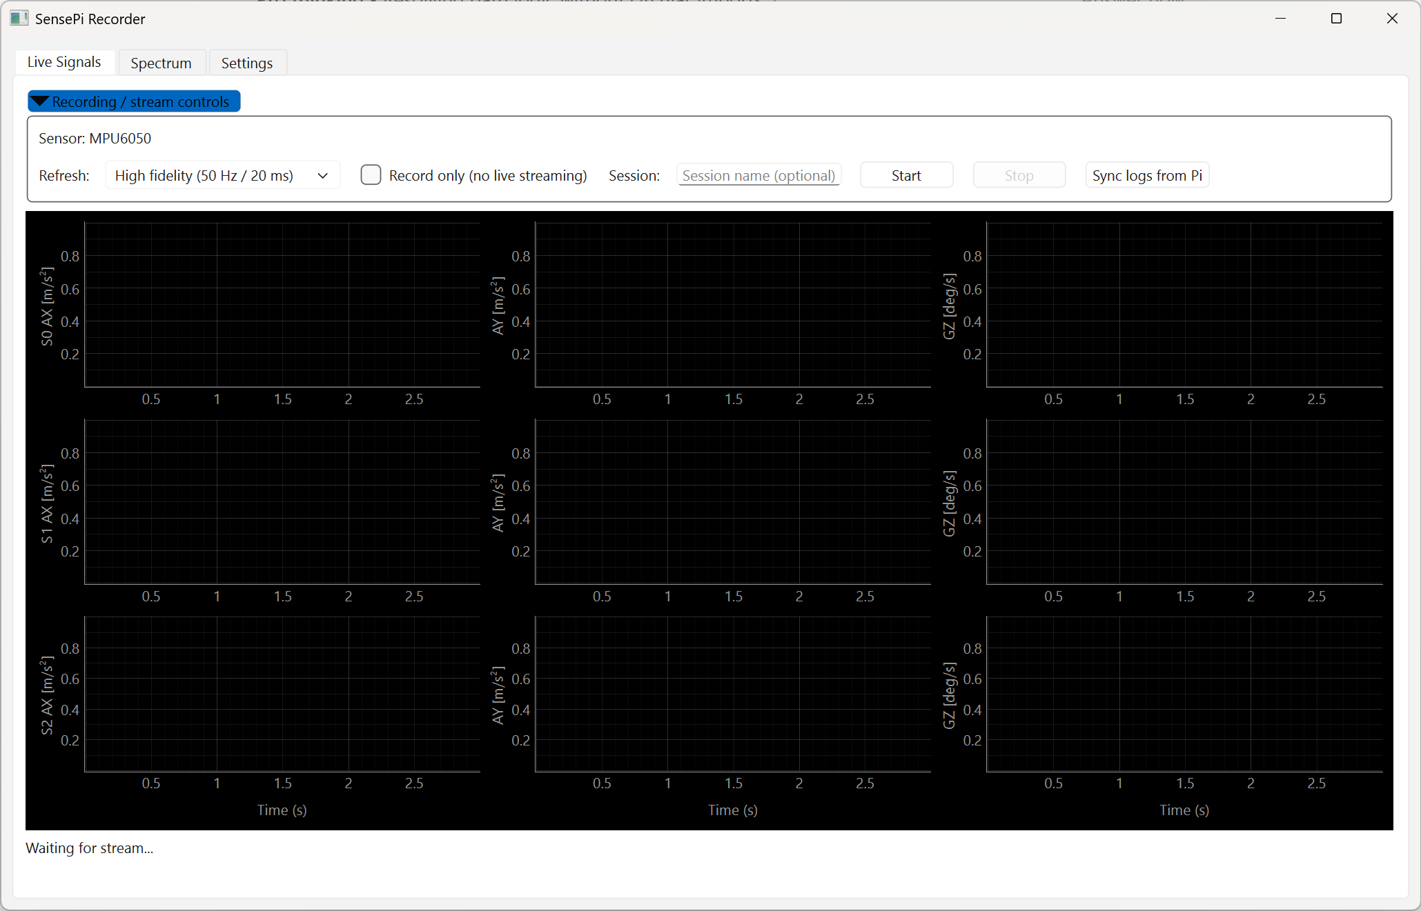
Figure 2: Main window tabs.

3. Make sure the Raspberry Pi is running
Before configuring sensors, confirm the Pi is powered and reachable.

3.1 Quick physical / network checks (outside the GUI)
- Power: Pi is powered (power LED on).
- Network: Pi is on the same network as the PC (Ethernet or Wi‑Fi).
- SSH enabled (required by SensePi): you can SSH into the Pi from another terminal if needed.
Note: The IP address of the SensePi is 10X based on the label at the back of the case.

3.2 Confirm the Pi is reachable using the GUI
1. Open the Settings tab.
Select your Pi in the Raspberry Pi hosts list (or add it if it’s not listed).
Click save hosts.yaml and save sensors.yaml. Then press on Sync Pi defaults (pi_config.yaml)
If the sync succeeds, the Pi is reachable over SSH and SensePi can access the expected remote folders.

If the sync fails
Most failures mean one of these is wrong:
- Host/IP, username, or password
- The remote paths (scripts folder / data folder) don’t exist yet on the Pi
Fix the host fields in Settings and try again.

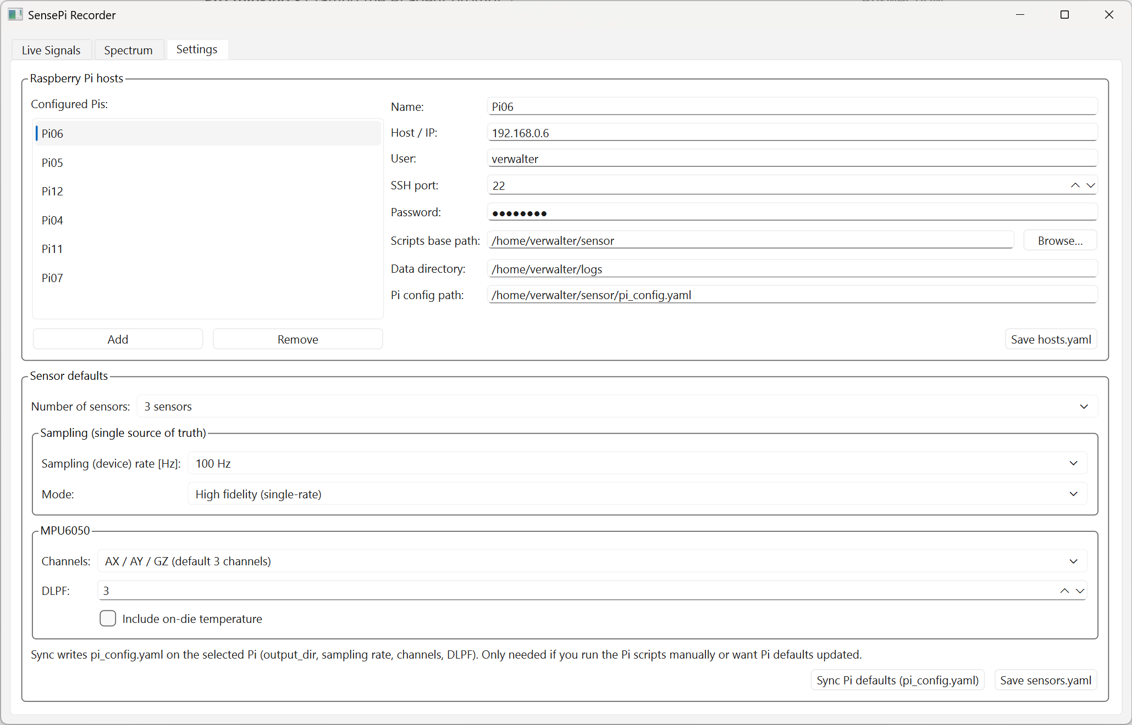
Figure 3: Settings tab: “Sync Pi defaults (pi_config.yaml)” button.

4. Settings tab: select a host (or add your Pi)
The Settings tab contains a full host editor: a list of hosts on the left, and editable fields on the right.

4.1 Select an existing Pi host
Go to Settings.
In Raspberry Pi hosts, click your Pi’s name.
Confirm the fields are correct (IP/hostname, user, port, password, paths).

4.2 Add a new Pi host (if your Pi is not listed)
In Settings → Raspberry Pi hosts, click Add host.
Fill in the host fields (typical examples):
Name: a friendly name, e.g. `LabPi`
Host / IP: e.g. `192.168.0.105`
User: verwalter
SSH port: 22
Password: 66442200
Scripts base path: where the SensePi scripts live on the Pi (e.g. /home/verwalter/sensor)
Data directory: where recordings/logs should be saved (e.g. /home/verwalter/logs)
Pi config path: path to `pi_config.yaml` on the Pi (e.g. /home/verwalter/sensor/pi_config.yaml)
Click Save hosts.yaml.

5. Settings tab: choose sensor IDs (MPU6050)
SensePi’s default logger supports up to 3 MPU6050 sensors and uses numeric sensor IDs.

5.1 Choose how many sensors you have
- In Settings, find Sensor defaults (and the MPU6050 group).
- Set Number of sensors to:
- `1 sensor` (uses sensor ID 0)
- `2 sensors` (uses sensor IDs 0-1)
- `3 sensors` (uses sensor IDs 0–2)
- Click Save sensors.yaml.

5.2 Choose channels (3‑axis vs 6‑axis)
In the same MPU6050 area, set Channels to match what you want to stream/record:
- `AX / AY / GZ (default 3 channels)`
- `AX / AY / AZ (acc only)`
- `GX / GY / GZ (gyro only)`
- `AX / AY / AZ / GX / GY / GZ (6-axis)`

5.3 DLPF
set the low pass filter, as per the datasheet of the sensor. Hover on the box to see what are the filtering frequncies for both angular velocity and accelerlation for every filter level.

5.4 Push the Settings to the Pi
After updating hosts or sensor defaults:
Select the correct Pi host in Settings.
Click Sync Pi defaults (pi_config.yaml).
This pushes the sensor defaults into the Pi’s `pi_config.yaml` and is also the easiest “one-click” way to confirm the Pi is reachable.

6. Live signals
Once your Pi host and sensor selection are correct:
Go to the Live Signals tab.
Enter an optional Session name.
Click Start to begin streaming.

For recording, Press only, which will start recording and save the file on the Pi. Then to get the recorded files, press on Sync logs from Pi and they will be copied to your local folder where you run the code from.
Note: The reason the recording is not accompanied with the live stream is that it allows you to record at higher sampling rate without much overruns (having the pi struggle to both send the data and record it locally).
Figure 4: Live Signals: Session / Start / Stop.

- Spectrum
Shows the frequency spectrum using FFT per channel per sensor for a certain time window, as shown in Figure 5.
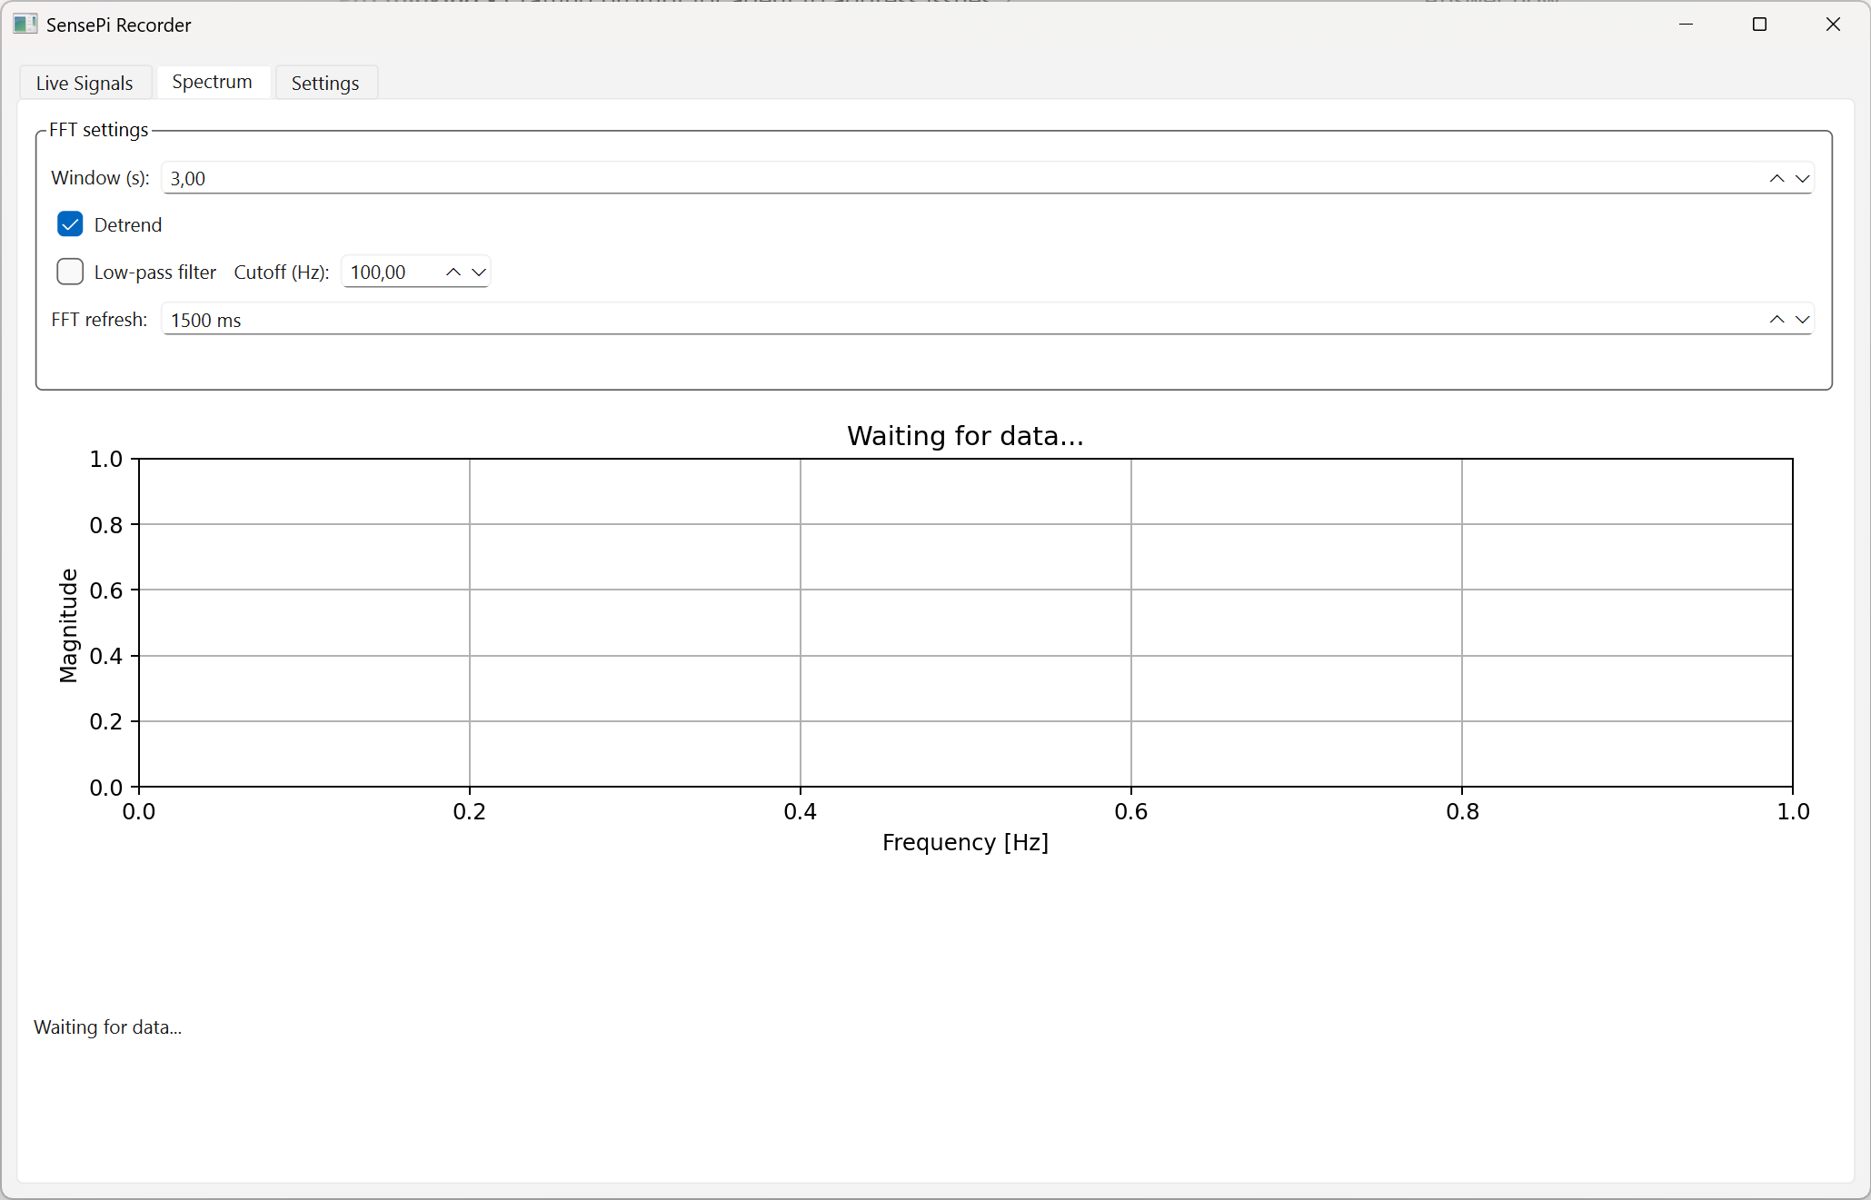
Figure 5: Spectrum tab.

